CHAPTER-3
DETAILED SURVEY

[2018] “Air pollution monitoring and prediction using IoT”, Temesegan Walelign Ayele, R. Mehta
The system employs IoT in conjunction with the machine learning method known as Recurrent Neural Network, specifically Long Short Term Memory, to monitor air contaminants (LSTM). The Internet of Things (IoT) essentially involves connecting electronics with an on/off switch to the network (or to one another). This includes nearly everything, including mobile phones, kitchen appliances, lights, and wearable technology. IoT refers to all web-enabled devices that collect, send, and track information from their surrounding environment using built-in sensors, processors, and communication tools. These "smart" or "connected" devices can occasionally interact with other similar devices and follow up on the information they receive from one another.
The strategy works well and yields mediocre outcomes. The results are not properly documented, and there is no finished product (IoT gadget). Improvement possible. The system has not been tested with real time data, nor does it have results published. It provides a Bird’s eye view of the architecture of the system and potential usage of it.
Air sensors are used by the system to detect and provide this information to the microcontroller. The data is then stored by the microcontroller on the web server. It uses the LSTM for prediction. It minimises the training cycles with good accuracy and provides a speedy convergence.
The paper also gives a brief introduction to the potential harmful effects of prolonged exposure to these pollutants (Sulphur Dioxide, Nitrogen Dioxide, Ozone, etc.)

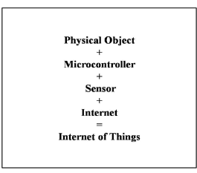

Fig 3.1 Basic Components of IoT

[2021] “Air Pollution Monitoring and Prediction Using IoT and Machine Learning”, Ssneha Balasubramanian et al.
In this paper, the authors propose an Internet of Things (IoT) system that makes use of a number of sensors, including the MQ135 and MQ131 sensors as well as the PM2.5 sensor, to record the current concentration levels of different pollutants and forecast the AQI for the next five hours using the linear regression, support vector regression, SARIMAX, and stacked ensemble models. The authors also go on to discuss the literature survey they have employed, and how they arrived at building the system.
The AQI values for the following five hours are predicted using a variety of Machine Learning models, including Linear Regression, Support Vector Regression, SARIMAX time series, and Stacking ensemble models. The Stacking Ensemble model has the lowest Root Mean Squared Error value when the Root Mean Squared Error values of all the models are compared.
Their proposed system architecture is to connect the sensors to Aduino Uno, which is connected to the Cloud using Node MCU. Then the prediction is made using the Machine Learning model.
This study forecasts the AQI value for the next 5 hours using a variety of machine learning models, including Linear Regression, Support Vector Regression, SARIMAX time series models, Stacking Ensemble, etc. The Stacking Ensemble model is the final model selected for use since it performs the best when the RMSE of all the models is compared.

[2022] “Air Quality Monitoring And Prediction Using IOT And Machine Learning Approaches”, T.S. Kitchilan, M.D.B.C.K. Abeyratne
In this work, sensors built on the Arduino platform were used to create a device for measuring air quality. The sensors were then calibrated to increase accuracy. Forecast models for pollutant concentrations were created using random forest as the basic model to forecast PM2.5 air quality index utilising data from the air quality sensor over a period of three months.
The study mainly focussed on the minute details of developing and deploying a portable and easy on the pocket device to capture and measure the parameters that determined the Air Quality.
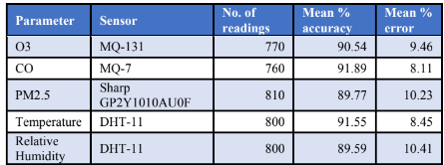
The authors of this paper have made use of the MQ-131 sensor for Ozone 3, MQ-7 sensor for Carbon Monoxide, Sharp GP2Y1010AU0F for PM 2.5, DHT-11 for temperature and humidity.

Fig 3.2 Accuracy of sensors

After the sensors were calibrated, the produced Internet of Things gadget performed with a noticeably higher level of precision. In terms of prediction accuracy, Random Forest Trees surpassed linear regression, decision trees, and neural networks, while runtime efficiency was much enhanced by the use of split data techniques and a Bayesian method for parameter tuning.
The gadget underwent testing and validation, and the results showed an overall accuracy of about 91%. The produced air quality system's accuracy has increased by about 6% to 11%, demonstrating the beneficial effects of the study's calibration techniques.
This work has shown the potential for creating air quality monitors that are affordable, portable, and accurate, allowing for effective real-time monitoring of air quality.
In this investigation, it became clear that the non-linear ensemble technique performed better, demonstrating that the idea that non-linear regression techniques are superior at predicting air quality metrics is supported by this finding. It also demonstrates how an accurate air quality forecast model can be successfully implemented using the Bayesian technique.
Additionally, it has been shown that when used to predict the Air Quality Index, the ensemble machine learning technique outperforms more conventional gradient boosting and regression machine learning techniques in terms of accuracy and efficiency.

[2019] Air Quality Prediction using Machine Learning Algorithms, Sachin Bhimrao Bhoite et al.
In many industrial and urban regions nowadays, monitoring and preserving air quality has become one of the most crucial tasks for the government. The burning of fossil fuels, traffic patterns, and industrial variables all have a big impact on air pollution. Due to the rising levels of air pollution, it is essential to implement models that will track data on the concentrations of air pollutants (so2, no2, etc.). The dataset is divided into Train, Validation, and Test in the ratio 0.8: 0.2: 0.2 on Kaggle. A time series model was developed once the data was analysed. Auto Regressive models and ARIMA were employed.
This paper discusses the various Machine Learning models that can be employed to solve the problem of predicting the quality of air. However, this research does not talk about the collection of data, rather uses pre collected data to build the models. It provides a good comparison between the various models.
The dataset was obtained from Kaggle. The Mean Squared Error reported by the model is 166.358. The paper only does it for the Maharashtra region, not for the entire nation.
The time series model of autoregression predicts the value at the following time step using observations from prior time steps as input to a regression equation. It is a pretty straightforward
concept that can produce precise predictions for a variety of time series issues. A class of statistical models for assessing and predicting time series data is known as an ARIMA model. With the addition of integration, ARIMA is an extension of the more straightforward Auto Regressive Moving Average.

[2020] “Adaptive machine learning strategies for network calibration of IoT smart air quality monitoring devices”, Saverio De Vito, et al.
Air Quality Multi-sensors Systems (AQMS) are Internet of Things (IoT) devices based on inexpensive chemical microsensor arrays that have recently demonstrated their ability to produce reasonably accurate quantitative estimates of air pollutant levels. Their accessibility enables the deployment of pervasive air quality monitoring (AQM) networks, which will address the geographical sparseness problem affecting the existing network of AQ Regulatory Monitoring Systems (AQRMS).
Urban authorities and monitoring agencies have recently become interested in the short- to mid-term performances of field data driven calibration models due to seasonal variations in the probability distribution of priors, observables, and hidden context factors (i.e., non-observable interferences).
Different combinations of updates periodicity and number of incoming GT labelled samples were investigated, with a focus on network calibration and applying online machine learning components. The results demonstrated the potential for a field deployed AQMS receiving regular or opportunistic input from high accuracy labelled data sources to significantly improve the performance achievable over more than one year.
Results also show that the number of labelled samples and update intervals are important factors in influencing final performances. To be more precise, the rarest updates need a higher percentage of tagged data to meet the same predetermined performance targets. A likely scenario for networked calibration updates, i.e. the daily updates utilising one hour of highly accurate data, can produce intriguing updates that are very near to results only possible with continuous calibration.

[2018] “Air Quality Prediction: Big Data and Machine Learning Approaches”, Gaganjot Kaur.
Numerous elements, such as time, place, and hazy circumstances, have an impact on air quality. Recent developments in big data applications, the availability of environmental sensing networks, and sensor data have led to an increase in the number of academics using the big data analytics approach. This research paper's goal is to examine various big-data and machine learning-based strategies for forecasting air quality.
This study analyses the findings of studies that have been conducted on decision trees, deep learning, and other AI-based techniques for evaluating air quality. It also sheds light on some of the difficulties and the requirements for further study.
The development of IoT infrastructures, big data technologies, and machine learning techniques has made it desirable for future smart cities to have real-time air quality monitoring and evaluation. This paper presents the results of our most recent literature analysis, analyses, and contrasts contemporary studies on the assessment of air quality using big data analytics, machine learning models, and methodologies. Finally, it offers a few insights regarding the problems, demands, and needs of future study.

[2020] “Real Time Localised Air Quality Monitoring and Prediction Through Mobile and Fixed IoT Sensing Network”, Dan Zhang et al.
Since the closest sensors may be miles away, the conventional method of deploying stationary sensors cannot efficiently provide a full perspective of air pollution in people's immediate surroundings. This study combines both stationary and mobile IoT sensors that are mounted on vehicles that patrol the area to predict the pattern of air quality in that area. With this method, the complete range of how air quality varies in close-by areas may be examined.
This study shows that the method can measure and forecast air quality accurately utilising data from the actual world and several machine learning methods. For a smart city application, this evaluation's outcome for good air quality monitoring and prediction is encouraging.
In this experiment, the authors deployed 3 fixed IoT sensors and 3 mobile IoT sensors fitted onto cars which were roaming around in a given locality.
A communication System was built to enable the different sensors to send back data to a central server through Voice over Long-Term Evolution(VoLTE). The collected data was Geo-tagged and stored in a Database. This data was used to predict the Air Quality metrics for the next day and compared with the ground truth to see how the models were performing. This paper also mentions the importance of being able to model the difference between weekends and weekdays.
A simpler way of doing that would be to add traffic density to the dataset.
By merging stationary and mobile sensors, a novel method for forecasting the immediate air quality around people was investigated in this research. The outcomes of the experiments demonstrate how well our suggested hybrid distributed fixed and IoT sensor system predicts the quality of the air near humans. Additionally, by using public transportation systems like buses and taxis—which are already fitted with IoT sensor devices to assess various areas—the proposed system can be made practically realisable. The system's forecasted air quality data can be used in a variety of situations, such as when making outdoor activity plans.

[2020] “IoT enabled Environmental Air Pollution Monitoring and Rerouting system using Machine learning algorithms”, Leeban Moses, et al.
Air quality index is a parameter that can be used to gauge air quality. Particulate matter (PM2.5 and PM10), ozone (O3), nitrogen dioxide (NO2), sulphur dioxide (SO2), and carbon monoxide are the main pollutants used to construct the air quality index (CO). In this study, the deployment of a cloud-based Internet of Things (IoT) system for monitoring air quality is discussed. Sensors are used to determine the levels of CO, PM2.5 and PM10, O3, SO2, and NOx pollution together with other environmental factors like temperature and humidity. By utilising Lora nodes and Lora Gateway, the acquired data may be updated on a cloud platform. The Google map API used in the development of the online application allows for frequent updates to the pollution status.
The prediction study for particulate matter was carried out using the neural network Multi-Layer Perceptron and Support Vector Machine Regression (SVMR) learning method with the acquired time series samples. This facilitates travel by automatically rerouting circumstances in a pollution-free environment.
AQI is expressed as a number between 0 and 500, with 0 denoting excellent air and 500 denoting hazardous air. The average concentration of a certain pollutant recorded over a predetermined period of time (24 hours for most pollutants, 8 hours for carbon monoxide and ozone) is used to calculate the air quality index (AQI). For instance, the 24-hour average concentration is used to calculate the AQI for PM2.5. An AQI's objective is to quickly disperse data on air quality (nearly progressive) that uses a framework to depict contamination that has transient impacts.
It is also crucial that a web-based monitoring system is used to continuously estimate the bulk of these poisons. Here is an online air quality monitoring network example of an AQI calculation and explanation for Coimbatore.
The AQI can be calculated as:
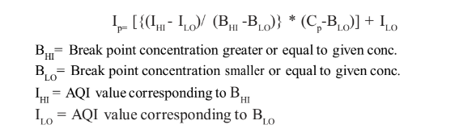
Fig 3.3 AQI Formula
In this study, the deployment of a cloud-based Internet of Things (IoT) system for monitoring air quality is discussed. Sensors are used to determine the levels of CO, PM2.5 and PM10, O3, SO2, and NOx pollution together with other environmental factors like temperature and humidity. NB IoT devices are used to communicate the estimated sensor readings into the network, where they are processed in a cloud environment. The estimated AQI value is used to update the maps' depictions of the pollution levels. A passenger can choose a route that doesn't cause pollution by using these updated values. By utilising a machine learning system to forecast the AQI value, the traveller can also schedule a trip in advance.

[2019] “Air pollution prediction through internet of things technology and big data analytics”, Safae Sossi Alaoui et al., Brahim Aksasse and Yousef Farhaoui
This paper brings together 3 important concepts of Big Data Analytics, Internet of Things and Data Science to be able to properly predict Air Pollution.
A quick and versatile cluster computing system, Apache Spark is an open source processing framework. It provides high-level APIs in several programming languages, including Java, Scala, Python, and R, and has an optimised engine that supports broad execution graphs. It also supports quick application development for huge data. Additionally, it offers a wide range of advanced tools, including Spark SQL for processing SQL queries and structured data, MLlib for machine learning (ML), GraphX for processing graphs, and Spark streaming.
Gradient-boosted Trees (GBTs) was the Machine Learning algorithm selected. Decision trees are iteratively trained by GBTs to minimise a loss function. GBTs are similar to decision trees in that they handle categorical features, can be applied to multiclass classification settings, don't require feature scaling, and can capture nonlinearities and feature interactions.
The 6 main steps for analysing data as well as building a GBT model are:
- Data pre-processing
- Setting up the environment
- Data Loading
- Data Splitting
- Data Modelling
- RMSE measuring

[2012] “Developing a risk-based air quality health index”, Tze Wai Wong, et al.
Based on the Canadian method, a risk-based, multi-pollutant air quality health index (AQHI) reporting system was created in Hong Kong. The relative risks of hospital admissions for respiratory and cardiovascular disorders linked to four air pollutants: sulphur dioxide, nitrogen dioxide, ozone, and particulate matter with an aerodynamic diameter less than 10 mm were
determined using time series analyses (PM10). These air contaminants' combined increased risks for hospital admissions were totaled up. The concentrations of these pollutants designated as short-term Air Quality Guidelines by the World Health Organization served as the basis for the cut-off values of the accumulated excess risk, for the issue of various health warnings.
The calculations performed to get the Air Quality Index from Pollutants like So2, No2, O3, PM10, etc. were observed and can be used in our project. Health advice was given as well.
For all age groups combined, the RRs of emergency hospital admissions for respiratory and cardiovascular disorders were considerably increased for all four air pollutants (NO2, O3, PM10, and SO2). In the 5-year study period, the extra risk of hospital admissions linked to air pollution ranged from 2.64% to 31.51%, with a median of 9.04% and a mean of 9.50%. Additionally, the health advice table is made public.
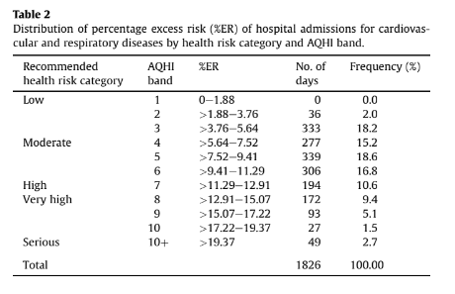
Fig 3.4 Distribution of %ER of hospital admission for cardiovascular and respiratory diseases
Table 2 displays the %ERs that served as the cut-off thresholds for the five risk categories. For the general public, a summed %ER of 12.91% was recorded (all ages). This became the criterion for inclusion in the "high risk" category. The 12.91% %ER was reduced to 11.29% for the vulnerable groups, which include both children under the age of five and seniors 65 years and older. 4 This served as the lowest cut-off for the category of "high risk." The lower cut-off point
for the "moderate risk" category was determined to be half of this (5.64%), and the %ER at or below 5.64% was classified as "low risk." The category of "severe risk" is associated with an ER of 19.37%.

[2021] “Air pollution monitoring system using IoT and Artificial Intelligence”, Meivel S, et al.

The paper proposes a system which keeps a track of combinations of gases such as CO2, methane and dust. The proposed model uses gas sensors which are responsible for detecting the gas level of the environment. Threshold levels for each gases are decided and the signals detected from the sensors are fed into the microcontroller. ESP8266 can fetch data and load into the Internet of things. By altering the resistance of the material inside the sensor, the sensor creates a corresponding potential difference based on the gas concentration, which may be quantified as output voltage. An alarm will sound if the concentration of any of the gases exceeds a predetermined level.
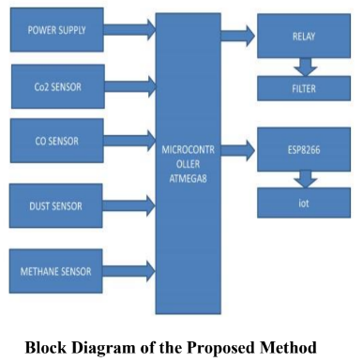

Fig 3.5 Block diagram of proposed model
The model created is a low-cost, high-fidelity air quality monitoring system. It is put in place, and tested. The system will collect data for each instant, send it through Wi-Fi, and notify the staff when the threshold level has been reached. The system will significantly meet a humanitarian need. By including more gas sensors, this prototype can be used to control air concentration in hospitals and research labs.

[2020] “Modelling air quality prediction using a deep learning approach: Method optimization and evaluation”, Weilin Wang, Limin Jiao, Suli Zhao, Anbao Liu et al.
In this article, a deep learning framework is introduced that uses a neural network with a temporal sliding long short term memory extended model (TS-LSTME) to forecast air quality over the next 24 hours. Through a multi-layer bidirectional long short-term memory (LSTM) that included the hourly historical PM2.5 concentration, meteorological data, and temporal data, the model incorporated the ideal time lag to realise sliding prediction. The suggested approach was used to forecast the upcoming 24-hour average PM2.5 concentration in China's most severely polluted region, Jing-Jin-Ji.
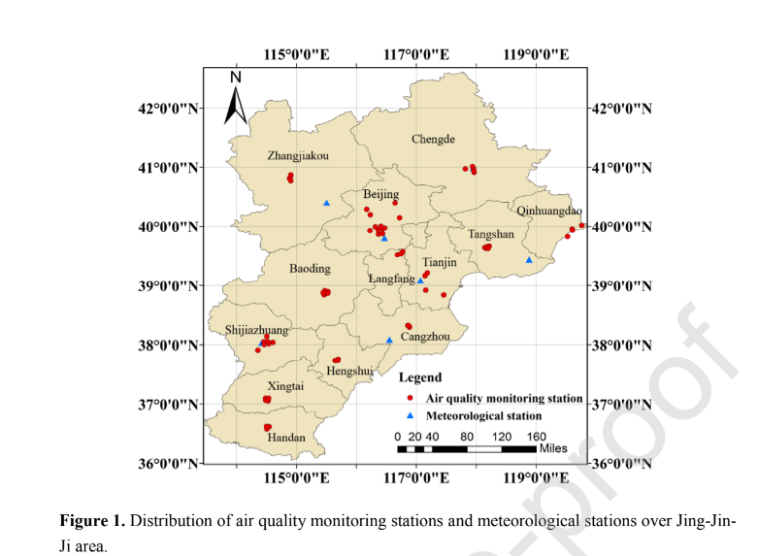
Fig 3.6 Distribution of air quality monitoring stations in Jing-Jin-Ji area
Additionally, the suggested model may produce highly accurate PM2.5 concentration estimates in long-term series (48 h and 72 h). The model was also put for predicting O3 concentration to the test. Other air contaminants might be subject to the proposed model's application. The suggested techniques can help early warning and regional pollution management while also enhancing public access to information services about air quality prediction.
The proposed model had better stability and performances with high correlation coefficient R Squared, compared to the multiple linear regression, support vector, the traditional LSTM, and the LSTME. The proposed model offers excellent practicability and is appropriate for long-term forecasting jobs.

[2020] “Impact of lockdown on air quality in India during COVID-19 pandemic”, Ramesh P. Singh, et al.

Using ground-based and satellite-based measurements, the air quality (particulate matter-PM2.5, Air Quality Index, and tropospheric NO2) across India is analysed in this work. Air quality index (AQI) and PM2.5 levels have significantly decreased. Tropospheric NO2 concentration also showed a lowering tendency over Delhi, Mumbai, Hyderabad, Kolkata, and Chennai during the lockdown period in 2020 compared to the same period in 2019. The air quality has greatly improved during the period of total lockdown, which gives the city administration crucial information for developing rules and regulations on how to improve air quality. The trajectory analysis was performed using HYPSPLIT model.

The figure depicts the effects of a total lockdown in India, the average PM2.5 concentrations for March 2020, the average PM2.5 concentration for March 2019, and the average PM2.5 concentration for March 2020 after the lockout period (March 22–31, 2020).

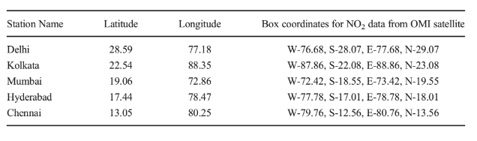
Fig 3.7 Location of US embassies in India

The association between PM2.5 and AQI and the fact that one of the main causes of poor air quality is vehicular motion were the paper's main findings. Following an analysis of India's biggest cities, it lists all the potential causes of air pollution.
In comparison to these sizable, densely populated urban footprints of India, where US embassies are situated, the lockdown appears to demonstrate a dramatic improvement in air quality. Our findings indicate a significant decrease in air pollution during lockdown, particularly in Delhi and Kolkata, which are known to have high levels of pollution in both India and the rest of the world.

[2018] “A Review on Indoor Air Quality Monitoring using IoT at Campus Environment”, Anindya Ananda Hapsari, et al.

Systems for improving indoor air quality (IAQ) offer a practical means of preserving a healthy atmosphere. This study's objectives are to examine IAQ monitoring systems, review prior research, and suggest future IoT-based IAQ monitoring investigations. The author of this systematic study summarises and analyses papers concerning IAQ utilising IoT that were pulled from three databases.

This study's objective is to evaluate an indoor air quality (IAQ) monitoring system that uses an Internet of Things (IoT) approach on a campus area by conducting a thorough evaluation of
previous research. The outcomes of the articles were divided into five categories in order to further examine the issue. The categories include IAQ monitoring system, IAQ on campus, IAQ data gathering, monitoring IAQ utilising Internet of Things, and IAQ monitoring problems. This study classified a different study that included IAQ and only focused on literature. The information gathered was reviewed carefully and extensively from sources that were relevant to the subject area.

The goal of this project is to make it easier for researchers to use the Internet of Things to build a monitoring system for indoor air quality. This article discusses the systems and categorises earlier relevant studies. Sensors, protocols, and the Internet of Things were used in the discussion material on monitoring systems to combat IAQ. The MQ gas sensor, DHT, and SHT are examples of inexpensive sensors that are frequently employed and can be used in an IAQ monitoring system. The study demonstrates that several nations consider the requirement for installing monitoring equipment in indoor spaces. Evidence that many researchers study indoor air quality (IAQ) each year shows that it is still an issue worth talking about. Additionally, IAQ topics utilising the Internet of Things must be created for sustainable development.

[2017] “.Air Quality Monitoring System Based on IoT using Raspberry Pi”, Somansh Kumar, et al.

An independent real-time air quality monitoring system is presented in this paper. A cutting-edge method for better managing data from various sensors may be found in the Internet of Things and cloud computing. This data is collected and transferred by the low-cost, ARM-based Raspberry Pi minicomputer. The system is tested in Delhi, where measurements are tabulated and compared with information from the regional environment control authority.
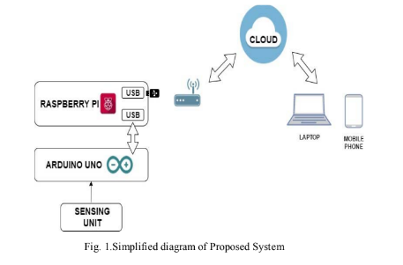
Fig 3.8 Diagram of the proposed system

The sensor-based air quality monitoring system is very accurate, reasonably priced, and simple to operate. A PM sensor, DSM501A, is interfaced to Arduino's digital pin 5, while DHT22 and BMP180 are attached to its digital pins 3 and 4, and MQ135 and MQ9 are connected to its analogue pins 2 and 3. A USB cable connects Arduino to Raspberry Pi. A Wi-Fi adapter is used to connect Raspberry Pi to the internet, and Raspberry Pi is connected to the adapter through a USB port.
A cutting-edge method for better managing data from various sensors may be found in the Internet of Things and cloud computing. This data is collected and transferred by the low-cost, ARM-based Raspberry Pi minicomputer.

[2020] “Air Quality Index Forecasting using Auto-regression Models”, Nimisha Tomar, et al.
This study's goal is to develop a daily AQI forecasting model that may be used for local and regional air quality management. Both the causes and the effects of air pollution are greatly influenced by meteorological factors, such as wind direction and speed, humidity, temperature, rainfall patterns, and solar radiation, as well as artificial factors, such as gases produced by industrial waste, pollutant gases from vehicles, and used fuel from radioactive activity and hydrogen bomb testing.
Time series models have been shown to perform better than other models for data that is serially associated. So, the ARMA model is employed. Moving average is used here and AR stands for auto-regression. However, they do not apply to series that are not stationary. Therefore, the main challenge is to use stochastic models to stationarize and predict the time series if it is not stationary. Detrending, differencing, and other techniques can be used to change a non-stationary series into a stationary series.
The MSE was 27.00 when auto-regression was used on a time series dataset to forecast the Air Quality Index value seven days in advance. By reducing the distance between the present and the date on which the AQI value is to be forecasted, MSE can be kept to a minimum.

[2012] “Forecasting of daily Air Quality Index in Delhi”, Anikendar Kumar, et al.

Government organisations can utilise the Air Quality Index (AQI), which can be calculated using a formula based on an extensive examination of the concentration of air pollutants, to describe the state of the air quality at a specific site. The goal of the current work is to create a forecasting model for daily AQI prediction that can serve as the foundation for decision-making procedures.

In Delhi, three statistical models—principal component regression (PCR), time series auto regressive integrated moving average (ARIMA), and a combination of both (model 3)—are used to forecast the daily AQI for each season. Pollutant concentrations are used to evaluate the performance of all three models, and it is clear that model 3 performs the best in terms of agreement with observed values when compared to model 1 and model 2. The statistical parameters also support the same.

The performance of Model 3, which combines ARIMA and PCR to tackle the problem of utilising the autocorrelation and collinearity in the variables, is satisfactory. As a result, this model 3 can be used to anticipate air quality in additional Indian urban centres. Although the model is functioning satisfactorily, it still has a lot of uncertainty.

[2017] “Daily Air Quality Index forecasting with hybrid models: A Case in China”, Suling Zhu, et al.

The data from a series of pollution indicators cannot be adequately captured by the forecasting techniques now in use, such as multiple linear models, autoregressive integrated moving average (ARIMA), and support vector regression (SVR). As a result, it is necessary to provide new, efficient methods for predicting air pollution indexes. To overcome the aforementioned issues and improve forecasting accuracy, the major goal of this research is to create efficient forecasting models for regional air quality indexes (AQI). In order to forecast AQI data, two hybrid models (EMD-SVR-Hybrid and EMD-IMFs-Hybrid) are proposed.

The following are the main steps of the EMD-SVR-Hybrid model: The original AQI data is sorted using the data pre-processing technique EMD (empirical mode decomposition), yielding one group of smoother IMFs (intrinsic mode functions) and a noise series, where the IMFs hold the crucial data (level, fluctuations, and others) from the original AQI series. The sum of the IMFs is predicted using LS-SVR, and the residual sequence of LS-SVR is predicted using S-ARIMA (seasonal ARIMA). Additionally, EMD-IMFs-Hybrid forecasts each IMF individually using statistical models before combining the findings as EMD-IMFs.

Comparing the suggested hybrid models to ARIMA, SVR, EMD-GRNN, GRNN, Wavelet-GRNN, and Wavelet-SVR, they show higher predicting accuracy. As a result, the suggested hybrid models can be employed as efficient and user-friendly tools for managing and issuing air pollution warnings.
In addition, for AQI forecasting, hybrid models with EMD and residual revision, such as ARIMA, SVR, EMD-GRNN, GRNN, Wavelet-GRNN, and Wavelet-SVR, perform better than individual models and hybrid models without residual revision.

